TC-CMS-008
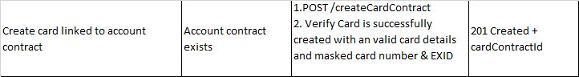
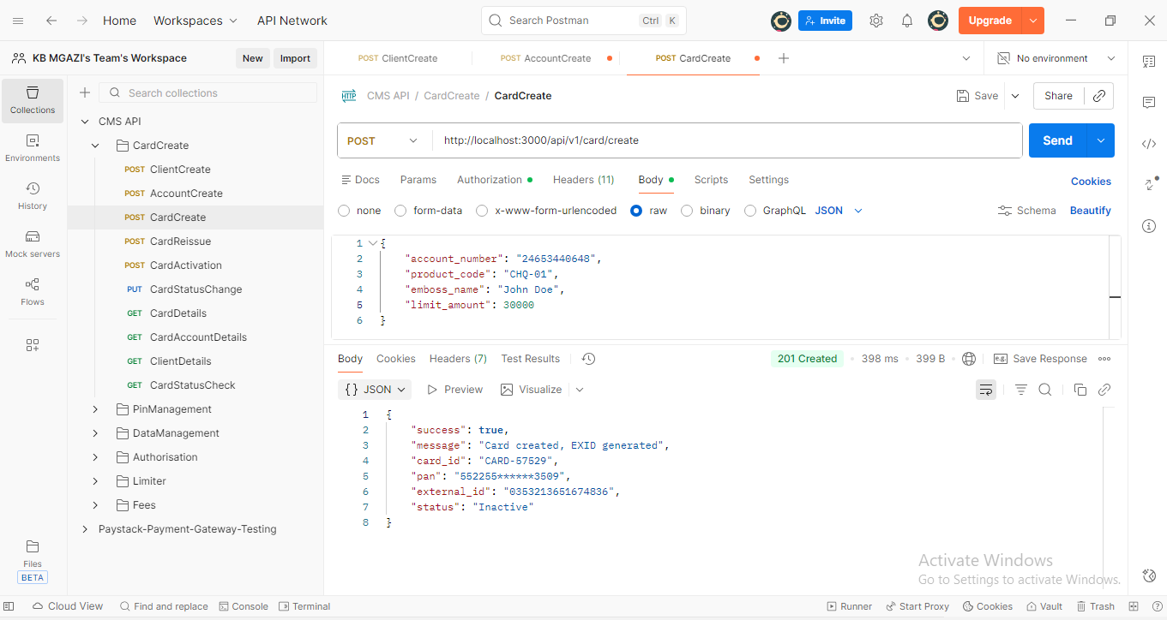
Request:
{
"account_number": "24653440648",
"product_code": "CHQ-01",
"emboss_name": "John Doe",
"limit_amount": 30000
}

Response:
{
"success": true,
"message": "Card created, EXID generated",
"card_id": "CARD-57529",
"pan": "552255******3509",
"external_id": "0353213651674836",
"status": "Inactive"
}

Card Successfully Created
